Hop Box Materials List

General Construction

* Sheet plastic for walls
* Angle aluminum for the sides and to hold it together (1”x1/16”)
* Sheet metal for top. This serves as the LED Driver and camera mount.
* Aluminum channel to fit plastic siding
* Bolts and wing nuts
* Hinge for door
* Aluminum foil for light reflection

Power Source and Lighting

* 14.8V battery (Tenergy #31069 Li-Ion battery)
  + Battery charger (Tenergy Smart Charger for 3.7-14.8V Li-Ion battery packs)
* On/off switch for power source/LED driver
* LDD H-4 driver board with spacers and screws (RapidLED)
* LDD-700H dimmable drivers (RapidLED)
* Rapid LED driver jumper (or other wire)
* Solderless LED plug (RapidLED)
* Solderless CREE XP-G3 Neutral White LED (RapidLED)
* Solderless LED to LED wire (RapidLED)

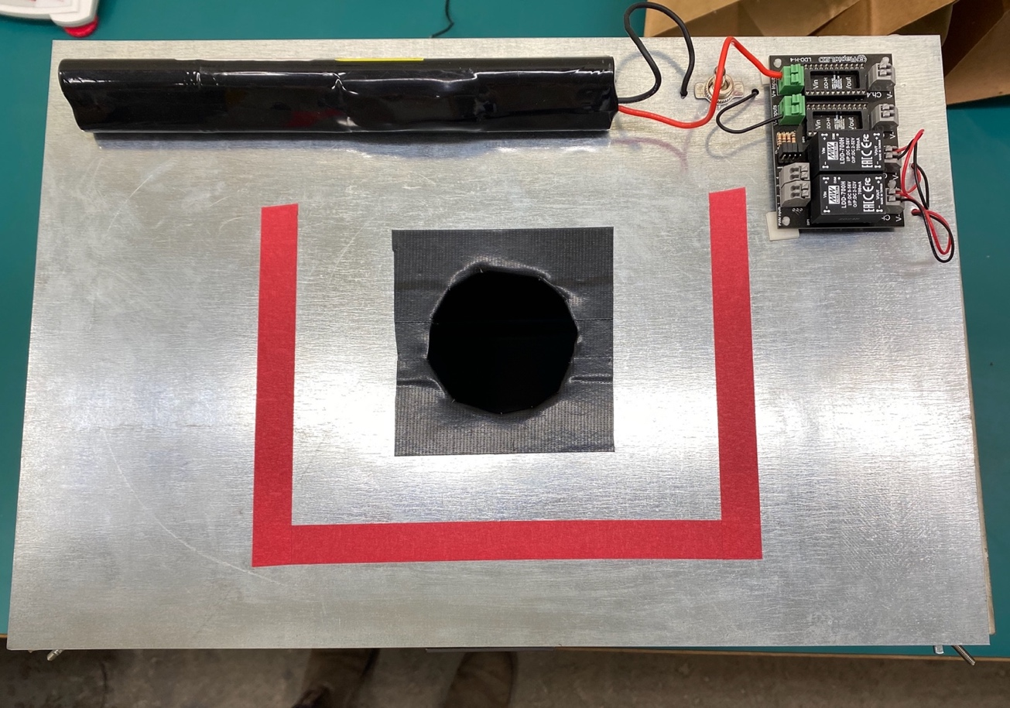

Top exterior view of Hop Box including the LDD-700H dimmable drivers, LDD H-4 driver board, On/Off switch, and 14.8V Tenergy battery.

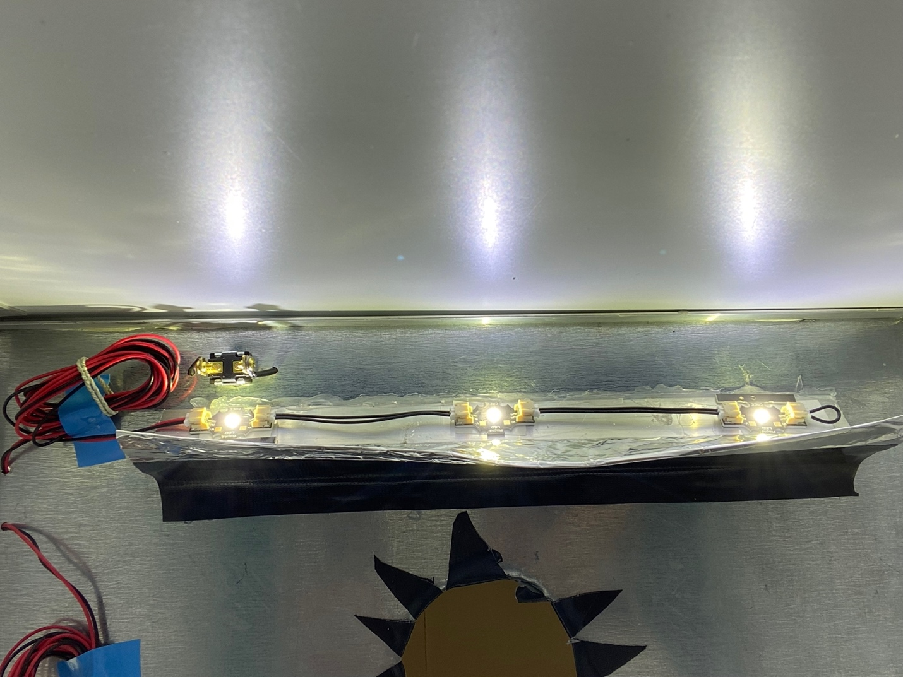

Interior of the Hop Box, including a string of three Solderless CREE XP-G3 Neutral White LED lights, Solderless LED to LED wire, Solderless LED plugs and aluminum foil shield for light reflection.

Camera and Mount

* DSLR Camera such as Canon EOS Rebel SL1
* Aluminum angles and channel supported by bolts can be used to create a mount
* Magnet to hold camera mount in place

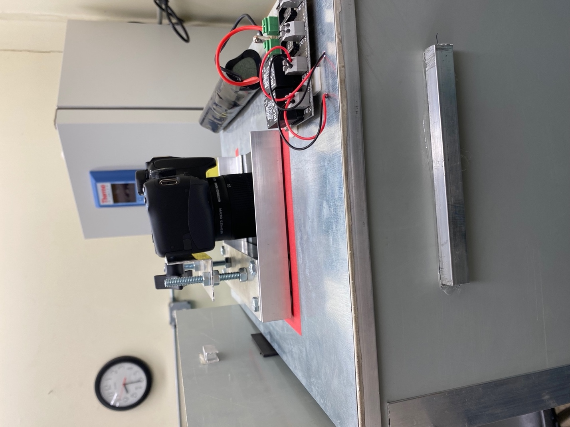

Camera mounted on top of the Hop Box.

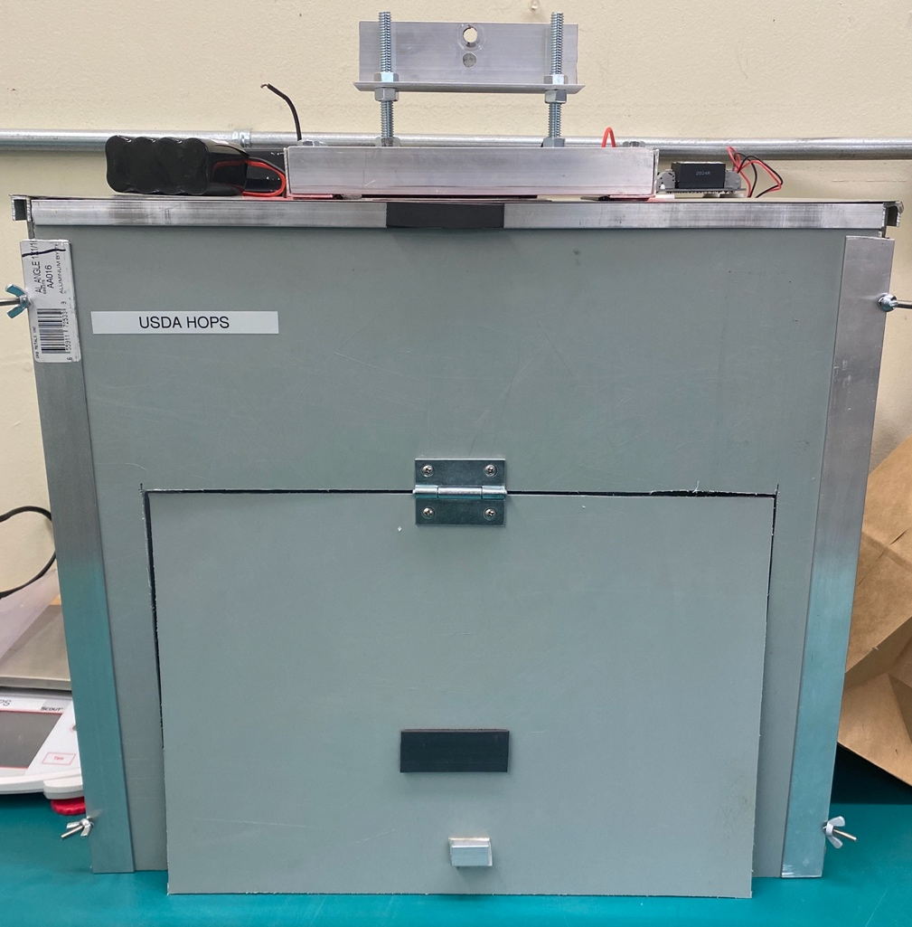

Exterior view of Hop Box, equipped with camera mount.